**Final Group Report – Fall 2019**

**Class: Quantitative Management Modelling**

**Instructor: Prof. Chaojiang (CJ) Wu**

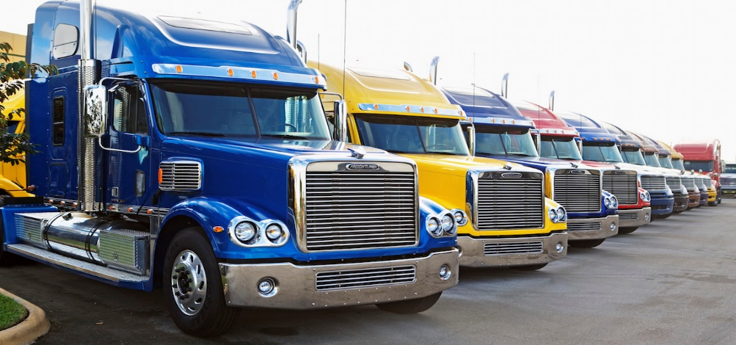

**Stateline Shipping cost Analysis**

Group Members:

Sushmita Singh 811066871

Sharmili Tandulwadkar 811072939

Sai Sumanth 811067798

Abstract

“Stateline Shipping and Transport” is our final group project for Quantitative Management Modelling (QM), Fall 2019 in the MSBA program with Instructor Dr. Chaojiang Wu. Our group consists of three members: Sushmita Singh, Sharmili Tandulwadkar and Sai Sumanth Avunuri Sampath.

In this project Rachel Sundusky is manager of South-Atlantic office of the Stateline Shipping and Transport Company. She wants to determine the shipping routes that will minimize Stateline’s total cost in order to develop a contract proposal to submit it to Polychem for waste disposal. She particularly wants to know if it would be cheaper to ship directly from the plants to the waste sites or if she would drop and pick up some loads at various plants and waste sites.

In the “Stateline Shipping and Transport” project, our group studies the situation, maps the problem processes and constraints, and develops a model utilizing linear programming with the objective of optimizing the purchase and allocation of coal so as to minimize total costs to purchase and use coal while satisfying all purchase contracts and meeting electricity demands. Ultimately, we successfully satisfy the project’s initial objective, delivering an optimized route which minimizes total costs and ship the waste disposal to the different plants and disposal sites.

TABLE OF CONTENTS

1. Agenda
2. Problem Formulation
   1. Case Overview – Description of Case
   2. Model Description
3. Approaches
4. Transportation Problem
   1. Network Diagram
   2. Objective Function
   3. Constraints
5. Transshipment Problem
   1. Network Diagram
   2. Objective Function
   3. Constraints
6. R Implementation
7. Conclusion
   1. Optimal Solution
   2. Future Scope

**1. AGENDA:**

**Problem Formulation**

**a. Case Overview – Description of Case**

**b. Model Description / Background**

a. Case Overview- Description of the case

Our project is based on a case selected from the textbook Introduction to Management Science, (11th edition) by Bernard W. Taylor III. The case is described as follows:

Rachel Sundusky is the manager of the South-Atlantic office of the Stateline Shipping and Transport Company. She is in the process of negotiating a new shipping contract with Polychem, a company that manufactures chemicals for industrial use. Polychem wants Stateline to pick up and transport waste products from its six plants to three waste disposal sites. Rachel is very concerned about this proposed arrangement. The chemical wastes that will be hauled can be hazardous to humans and the environment if they leak. In addition, a number of towns and communities in the region where the plants are located prohibit hazardous materials from being shipped through their municipal limits. Thus, not only will the shipments have to be handled carefully and transported at reduced speeds, they will also have to traverse circuitous routes in many cases.

Rachel has estimated the cost of shipping a barrel of waste from each of the six plants to each of the three waste disposal sites as shown in the following table:

|  |  |  |  |
| --- | --- | --- | --- |
| **Plant** | **Waste Disposal Site** | | |
| **Whitewater** | **Los Canos** | **Duras** |
| **Kingsport** | **$12** | **$15** | **$17** |
| **Danville** | **14** | **9** | **10** |
| **Macon** | **13** | **20** | **11** |
| **Selma** | **17** | **16** | **19** |
| **Columbus** | **7** | **14** | **12** |
| **Allentown** | **22** | **16** | **18** |

The plants generate the following amounts of waste products each week:

|  |  |
| --- | --- |
| **Plant** | **Waste per Week (bbl)** |
| **Kingsport** | **35** |
| **Danville** | **26** |
| **Macon** | **42** |
| **Selma** | **53** |
| **Columbus** | **29** |
| **Allentown** | **38** |

The three waste disposal sites at Whitewater, Los Canos, and Duras can accommodate a maximum of 65, 80, and 105 barrels per week, respectively. In addition to shipping directly from each of the six plants to one of the three waste disposal sites, Rachel is also considering using each of the plants and waste disposal sites as intermediate shipping points. Trucks would be able to drop a load at a plant or disposal site to be picked up and carried on to the final destination by another truck, and vice versa.

Stateline would not incur any handling costs because Polychem has agreed to take care of all local handling of the waste materials at the plants and the waste disposal sites. In other words, the only cost Stateline incurs is the actual transportation cost. So, Rachel

wants to be able to consider the possibility that it may be cheaper to drop and pick up loads at intermediate points rather than ship them directly.

The estimated shipping costs per barrel between each of the six plants to be as follows:

|  |  |  |  |  |  |  |
| --- | --- | --- | --- | --- | --- | --- |
| **Plant** | **Plant** | | | | | |
| Kingsport | Danville | Macon | Selma | Columbus | Allentown |
| **Kingsport** | **$ __** | **$6** | **$4** | **$9** | **$7** | **$8** |
| **Danville** | **6** | **__** | **11** | **10** | **12** | **7** |
| **Macon** | **5** | **11** | **__** | **3** | **7** | **15** |
| **Selma** | **9** | **10** | **3** | **__** | **3** | **16** |
| **Columbus** | **7** | **12** | **7** | **3** | **__** | **14** |
| **Allentown** | **8** | **7** | **15** | **16** | **14** | **__** |

Estimated shipping cost per barrel between each of the three waste disposal sites is as follows.

|  |  |  |  |
| --- | --- | --- | --- |
| **Waste Disposal Site** | **Waste Disposal Site** | | |
| Whitewater | Los Canos | Duras |
| **Whitewater** | $__ | $12 | $10 |
| **Los Canos** | 12 | __ | 15 |
| **Duras** | 10 | 15 | __ |

First, we defined our objective in solving the case problem:

**Objective:** The objective of the project is to determine the shipping routes that will minimize Stateline’s total cost in order to develop a contract proposal to submit to Polychem for waste disposal.

Construct a model by considering the optimal approaches that would minimize the cost.

1. Waste products can be shipped directly from waste disposal sites to each of six plants
2. Considering using each of the plants and waste disposal sites as intermediate shipping points

**Approach:**

* 1. **Transportation Problem**
  2. **Transshipment Problem**

**Transportation Problem Description**

Transportation problem deals with the distribution of goods from sources to destination.

It aims to find the best way to fulfill the demand of demand points using the capacity of supply points.

We are trying to find the best way generally a variable cost of shipping the product from one supply point to a demand point.

**Transportation Problem Formulation**

* The six plants will be considered as supply sources and three waste disposal sites are to be considered as destination.
* In transportation problem, Shipments will be shipped directly from each plant to waste disposal sites.
* The goal is to determine the optimal shipping route that will minimize Stateline company’s total cost.

Two Methods:

* Balanced Transportation Problem
* If total supply equals to total demand, the problem is said to balanced transportation problem
* Unbalanced Transportation problem
* If total supply exceeds total demand or vice versa we can balance the problem by adding dummy demand point or supply point, they are assigned a cost of zero.
* ***Since, we have demand more that total supply we have to add dummy variables to supply side.***

Network Diagram:

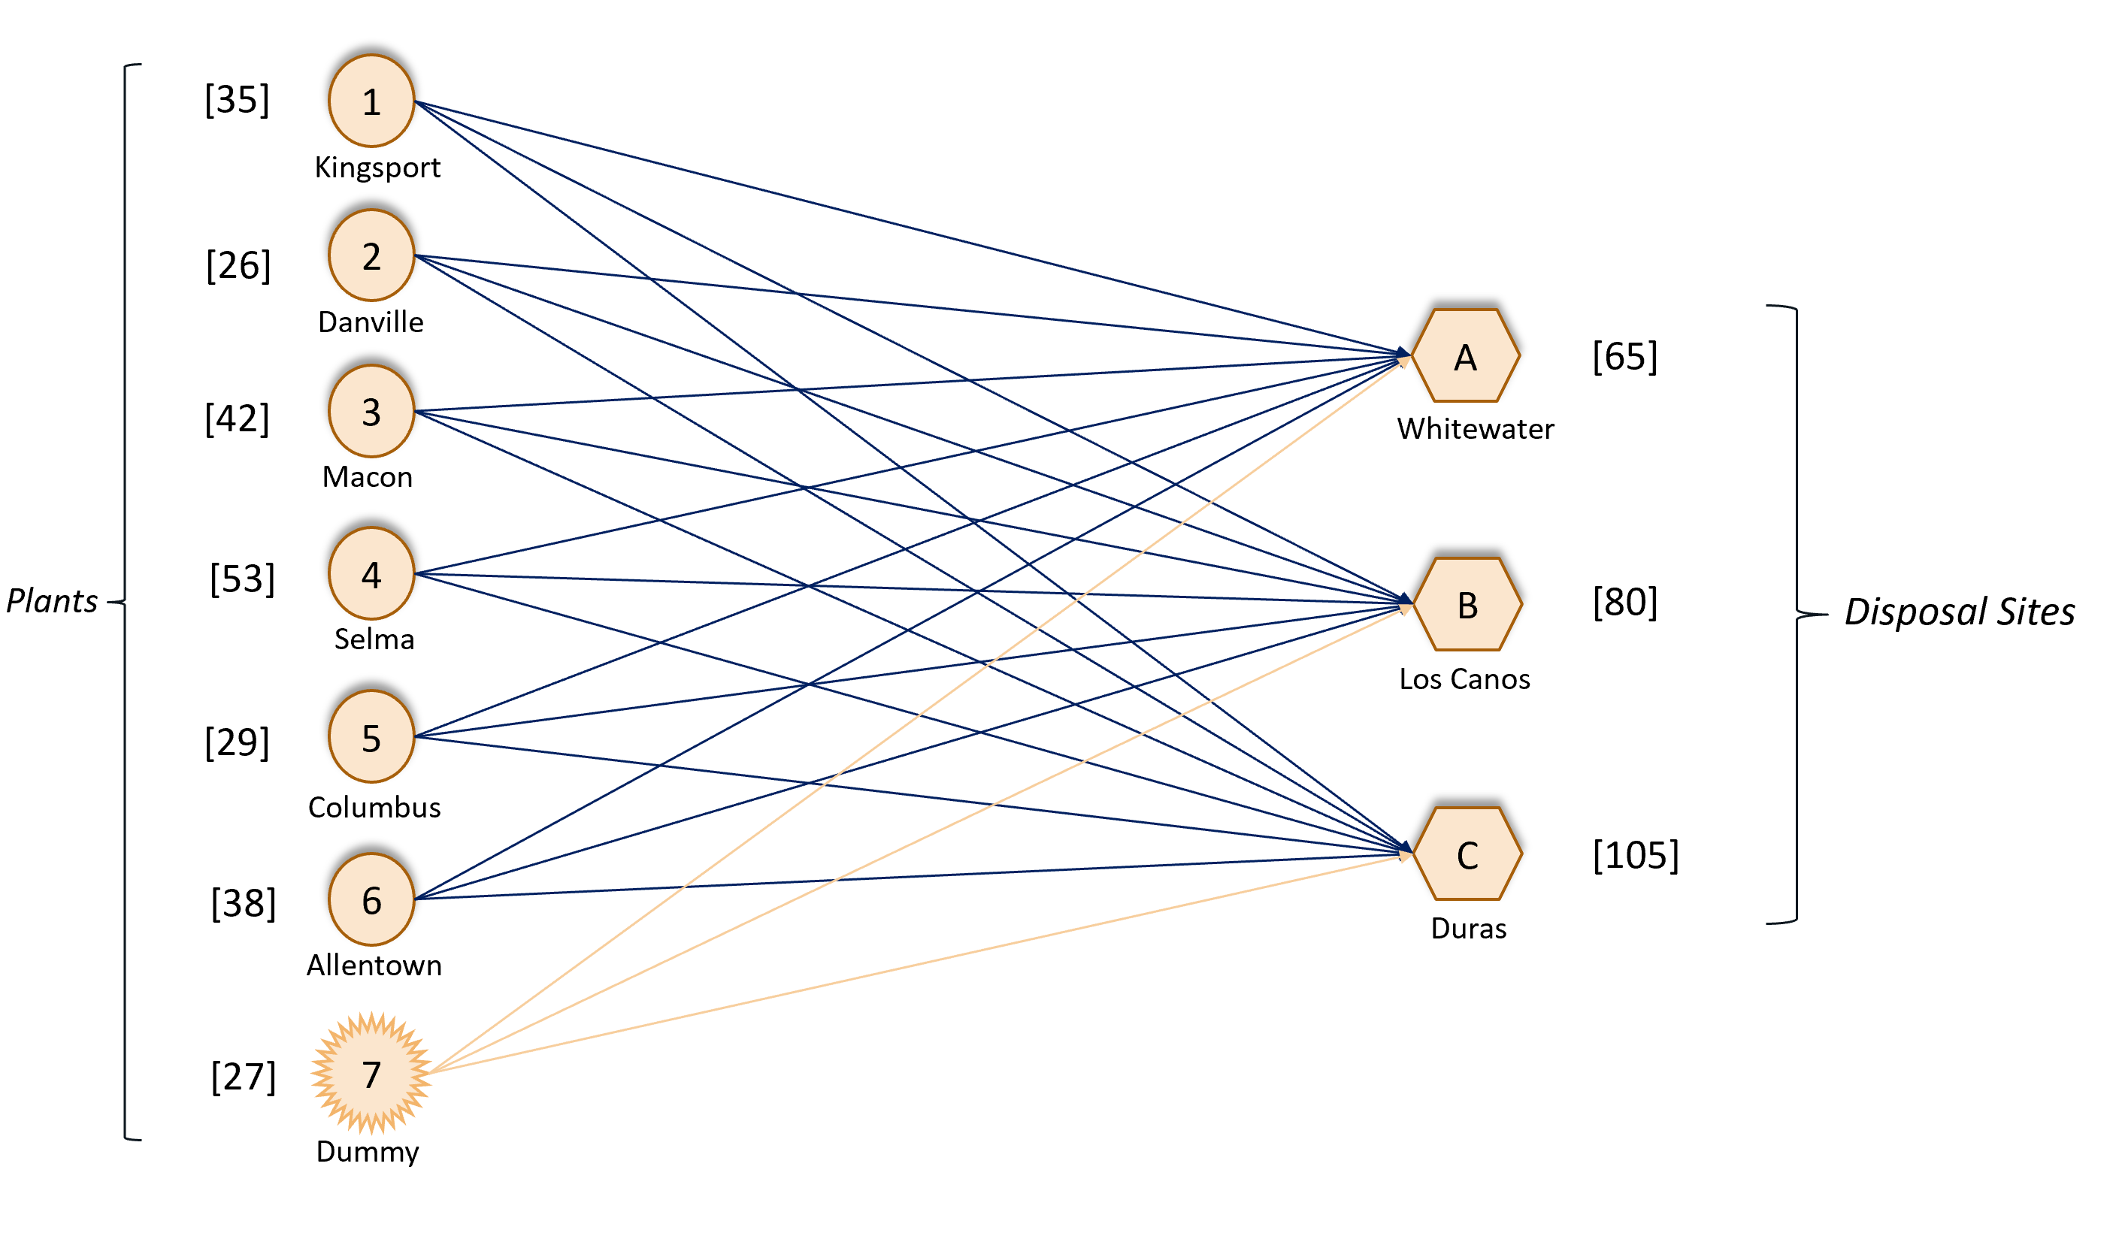

Mathematical Formulation

* Decision Variable:

Since we have to determine how much waste is send from each plant to destination point

Xij = The quantities of waste disposed from plant to disposed sites

Where,

i= 1,2,3,4,5,6,7 and j= A,B,C

OBJECTIVE FUNCTION

* Since we want to minimize the *total cost of shipping* from plant to disposal sites, the objective function would be

Minimum Z: 12 x1A + 15 x1B + 17 x1C + 14 x2A + 9 x2B + 10 x2C + 13 x3A + 20 x3B + 11 x3C + 17 x4A + 16 x4B + 19 x4C + 7 x5A + 14 x5B + 12 x5C + 22 x6A + 16 x6B + 18 x6C + 0 x7A + 0 x7B + 0 x7C ;

CONSTRAINTS

Supply Constraints

* x1A + x1B + x1C = 35;
* x2A + x2B + x2C = 26;
* x3A + x3B + x3C = 42;
* x4A + x4B + x4C = 53;
* x5A + x5B + x5C = 29;
* x6A + x6B + x6C = 38;
* x7A + x7B + x7C = 27;

Demand Constraints

x1A + x2A + x3A + x4A + x5A + x6A + x7A = 65;

* x1B + x2B + x3B + x4B + X5B + x6B + x7B = 80;
* x1C + x2C + x3C + x4C + x5C + x6C + x7C = 105;

R- Implementation

Optimal Path:

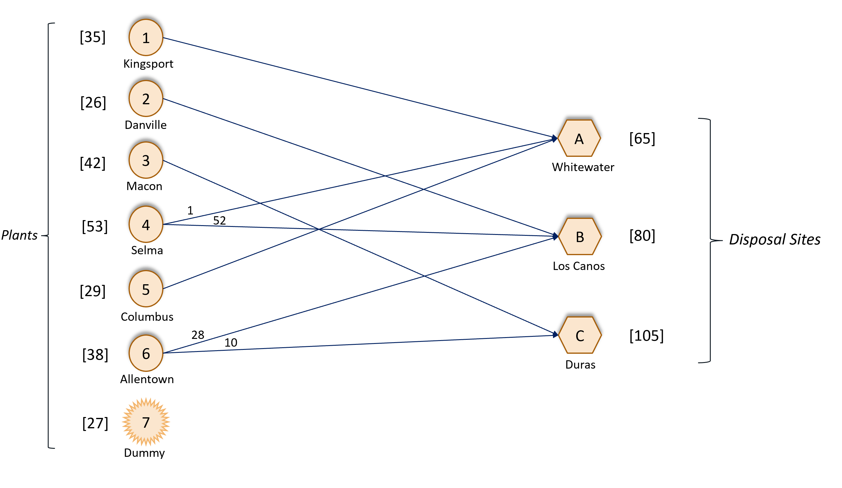

***If we go by the above optimal path, the total transportation cost would be***

***$2822.***

1. **Transshipment Problem Description:**

* Transshipment problem is an extension of transportation problem.
* In this, we are considering intermediate nodes between sources and destinations.
* The better analogy that explain transshipment model would be a warehouse where shipment arrives from factories and then leave for retail outlets.

Mathematical Formulation

* Decision Variable:
* Since we have to determine how much waste is send from each plant to destination point via intermediate node
* Xij , Xjk= The quantities of waste disposed from plant to disposed sites
* Where,
* i= 1,2,3,4,5,6,7, j= 1,2,3,4,5,6,7, A, B, C and k= A, B, C

Network Diagram:

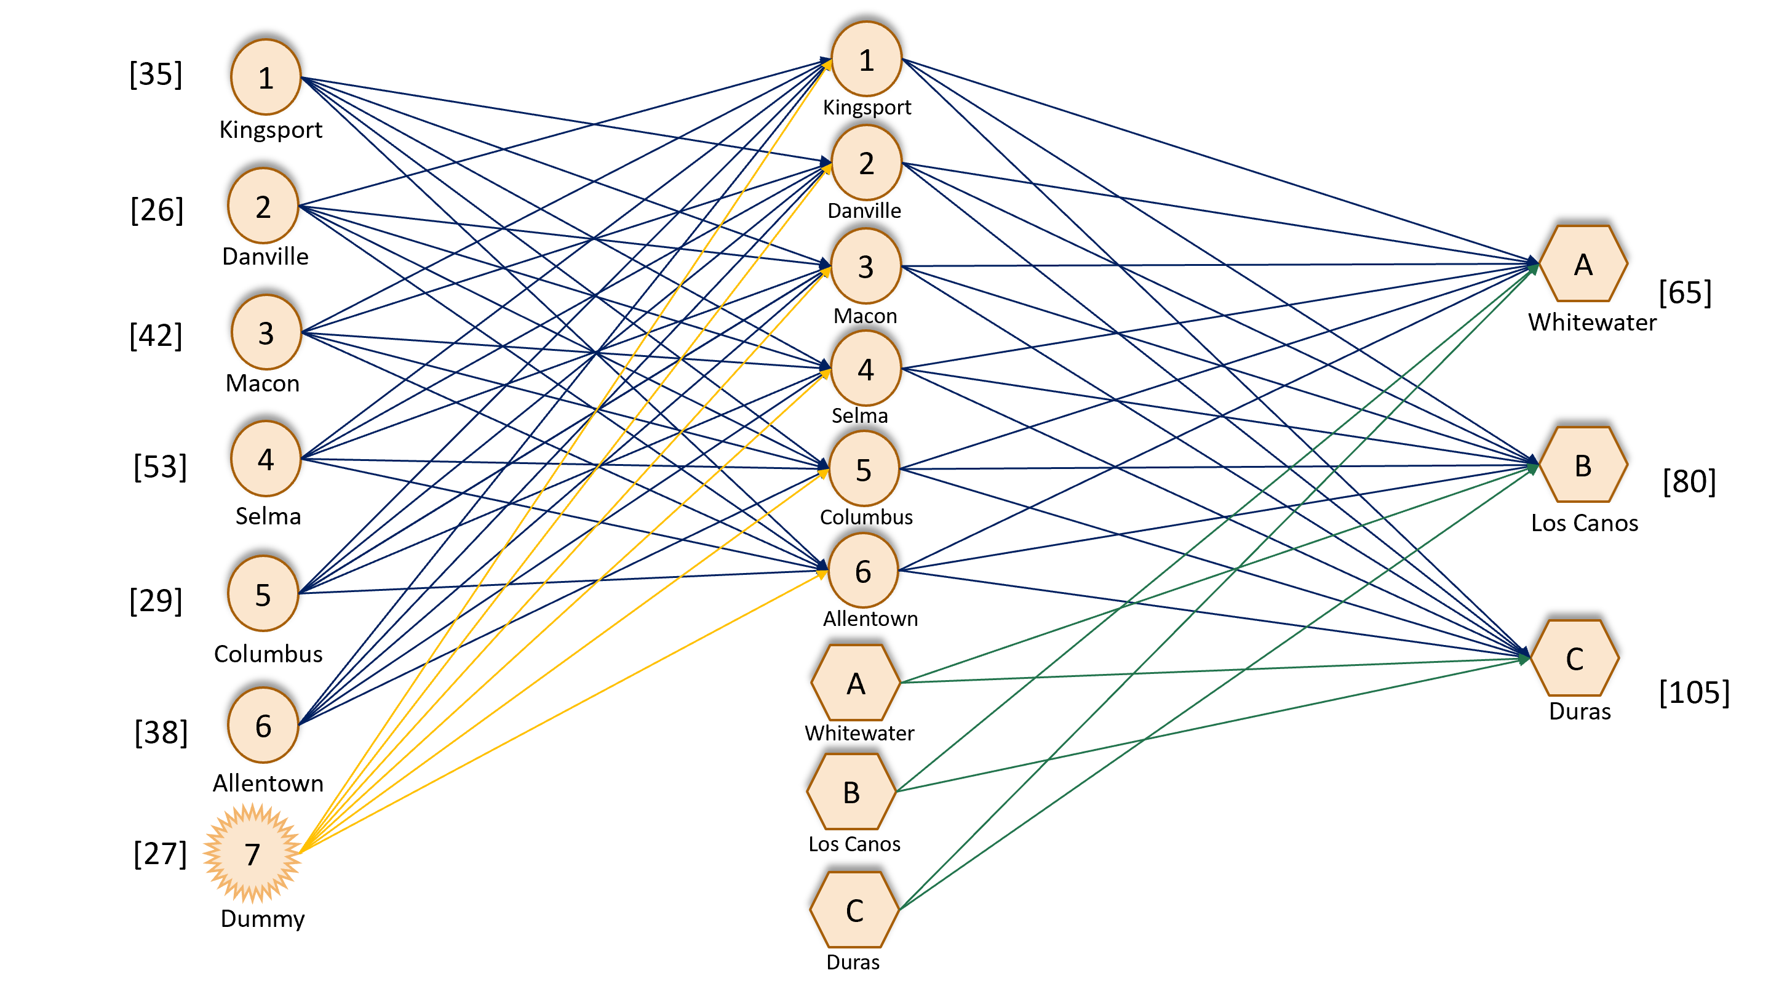

Constraints:

Supply Constraints:

* X12 + X13 + X14 + X15 + X16 = 35;
* X21 + X23 + X24 + X25 + X26 = 26;
* X31 + X32 + X34 + X35 + X36 = 42;
* X41 + X42 + X43 + X45 + X46 = 53;
* X51 + X52 + X53 + X54 + X56 = 29;
* X61 + X62 + X63 + X64 + X65 = 38;
* X71 + X72 + X73 + X74 + X75 + X76 = 27;

Intermediate Nodes constraints:

X21 + X31 + X41 + X51 + X61 + X71 = X1A + X1B + X1C;

X12 + X32 + X42 + X52 + X62 + X72 = X2A + X2B + X2C;

X13 + X23 + X43 + X53 + X63 + X73 = X3A + X3B + X3C;

X14 + X24 + X34 + X54 + X64 + X74 = X4A + X4B + X4C;

X15 + X25 + X35 + X45 + X65 + X75 = X5A + X5B + X5C;

X16 + X26 + X36 + X46 + X56 + X76 = X6A + X6B + X6C;

Demand Constraints:

X1A + X2A + X3A + X4A + X5A + X6A + XBA + XCA = 65;

X1B + X2B + X3B + X4B + X5B + X6B + XAB + XCB = 80;

X1C + X2C + X3C + X4C + X5C + X6C + XAC + XBC = 105;

R- Implementation

Optimal Path

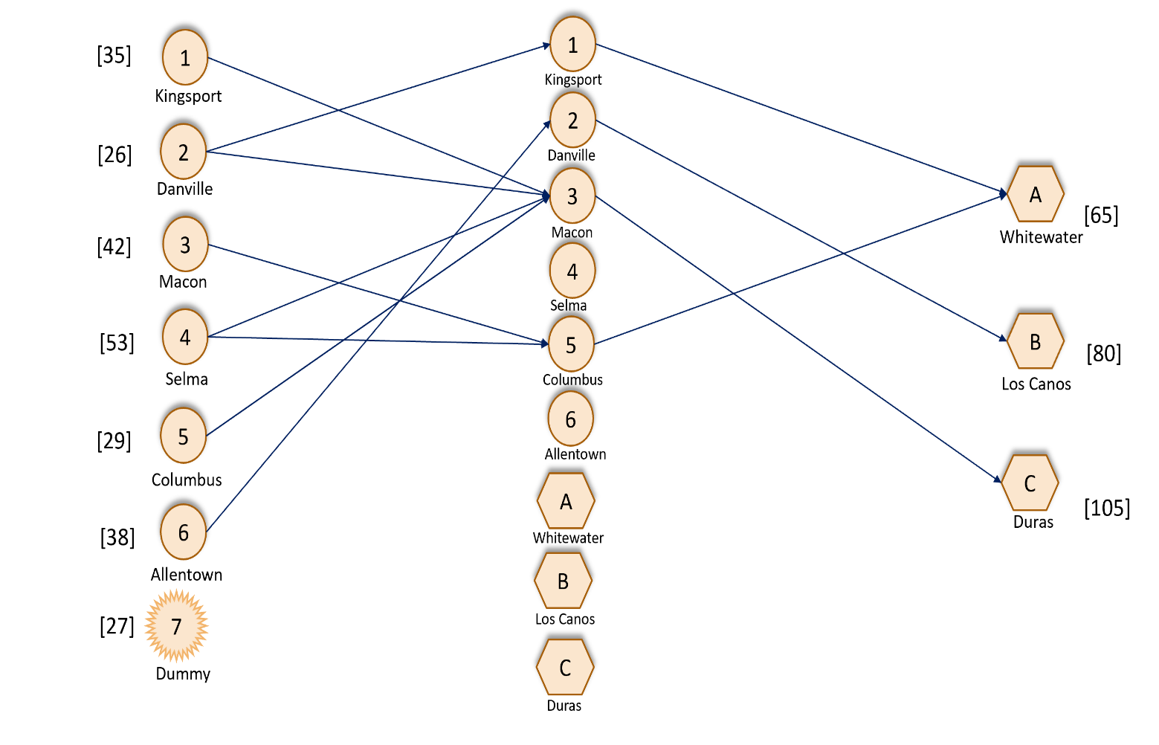

***If we go by the above optimal path, the total transportation cost would be***

***$3693***

**Conclusion:**

* The Transportation problem of the Stateline Shipping and Transport Company was mathematically modelled and analyzed.
* The minimum cost of the company was estimated as $2822.
* It is found that if we use certain intermediate points to drop the waste and then pick up from there to the final destination will increase the cost to the company i.e. $3693.
* Hence, the transportation model would be preferable over transshipment model.